Pascual, David Jonathan T.

2ECE-D

Problem 1

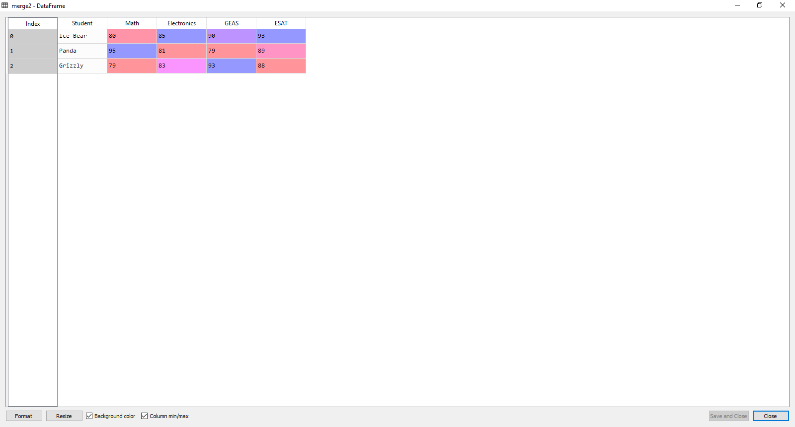

Long Format with Subject and Grades

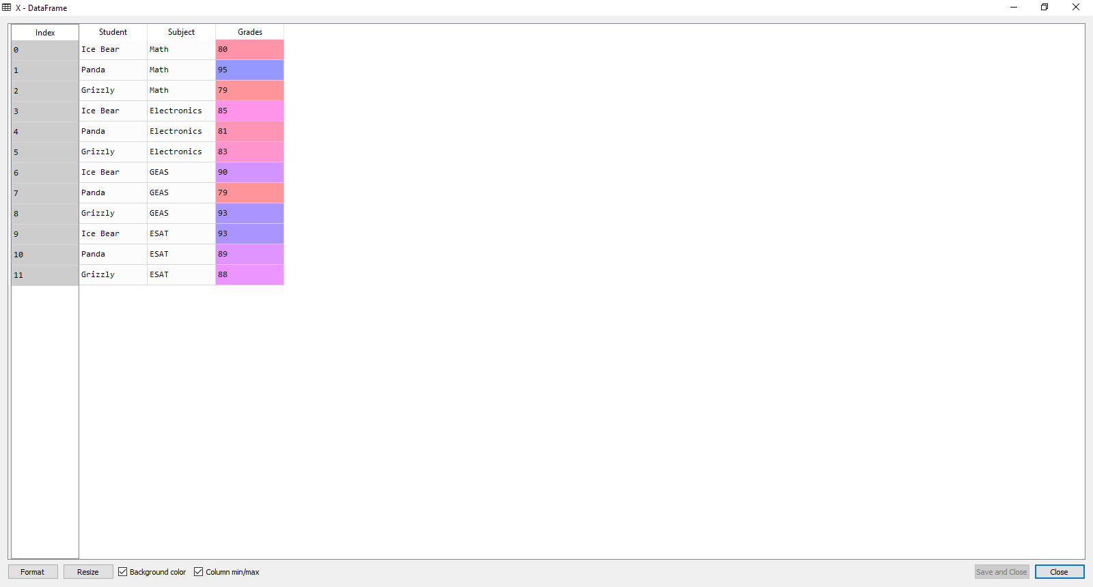

Problem 2

With New Column

